How to Initialize a Node.js Project

* Open Command Prompt.
* Enter “cd” followed by the folder you want to create the file in.
* Enter “npm init” to initialize.  
  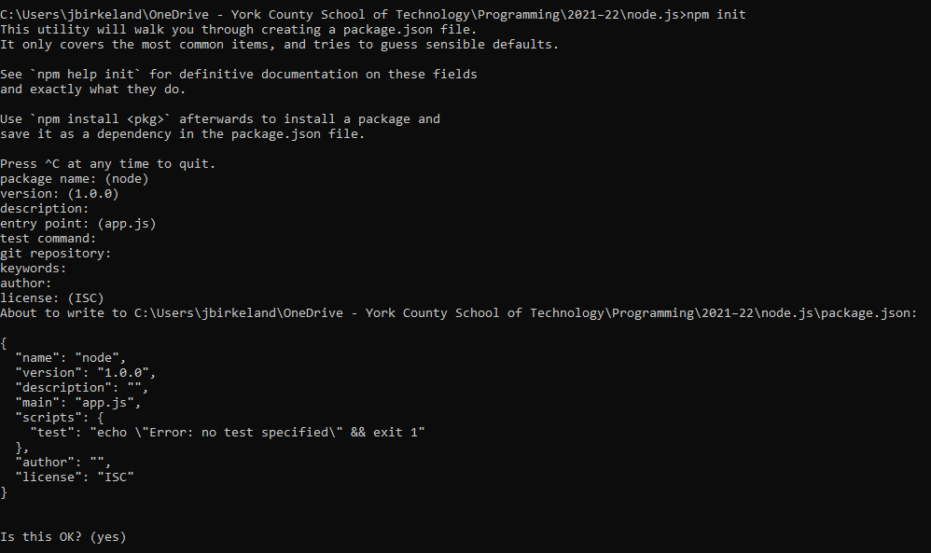A file called “package.json” is created. These are the properties of the file: 

How to Create a HTTP Server in Node.js

* Create a new file titled “app.js”
* Load the http module:

const http = require('http');

//defines hostname and port

const hostname = '127.0.0.1';

const port = 3000;

//Display a message when someone connects

const server = http.createServer((req, res) => {

res.statusCode = 200;

res.setHeader('Content-Type', 'text/plain');

res.end('message');

});

//creates a listener

server.listen(port, hostname, () => {

console.log('listening');

});

* In the command prompt, go to the correct folder with cd, then enter the following to run the command “node app.js”
* In the browser, type: localhost:3000

You should see a message on your screen now, showing that the server is running.